1. **Create s3 bucket and upload some objects to s3.**

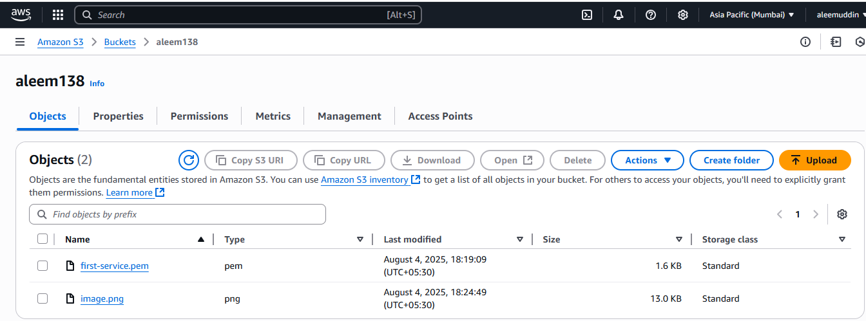

1. **Deploy static website in s3 bucket.**

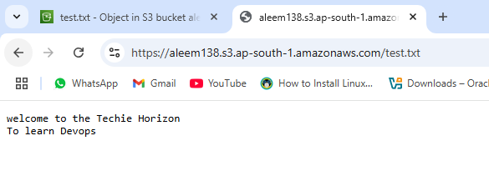

1. **Enable cross region replication on s3 buckets.**

**Step1 :Create two s3 buckets source and dest in diff. Region, with enable versioning on both S3**

**Step2 : Create Replication Rule in Source Bucket**

**Go to source bucket → Management tab → Replication rules**

**Click Create replication rule**

**Rule settings:**

**Name: replication-to-west**

**Status: Enabled**

**Scope: Leave as All objects (or filter by prefix/tag)**

**Destination:**

**Bucket: Choose your destination bucket from dropdown (in another region)**

**Permissions:**

**Select Create new IAM role (recommended)**

**AWS will automatically create a role with required permissions**

**Click Save**

**Step3: now upload a file in source s3 then open and check Replication status pending ,completed or fail and check in dest S3 is file showing or not.**

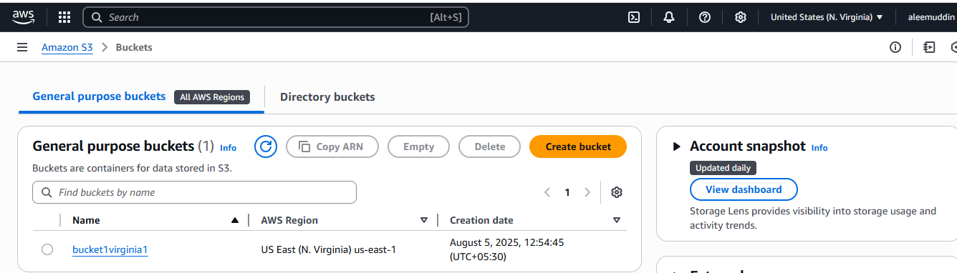

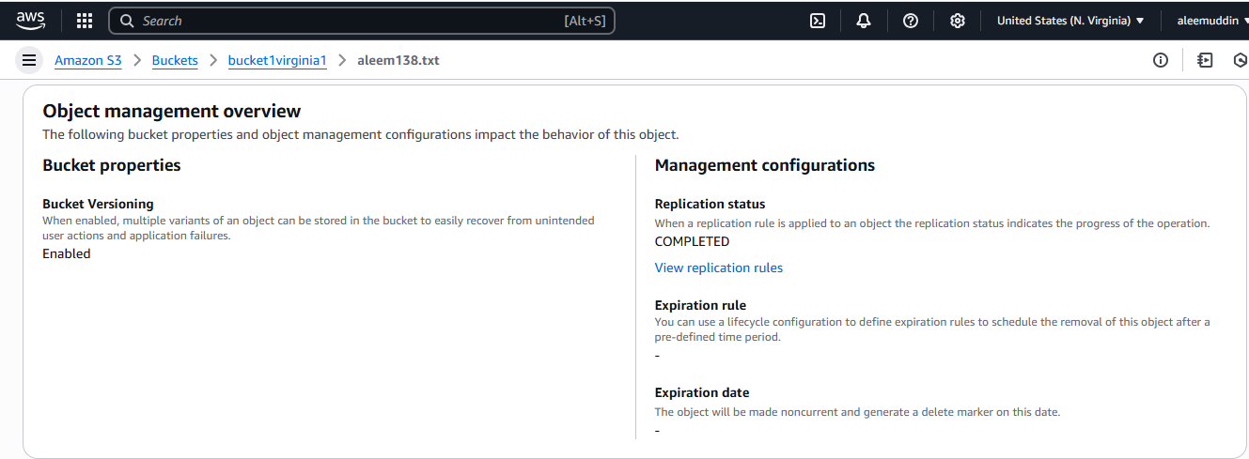

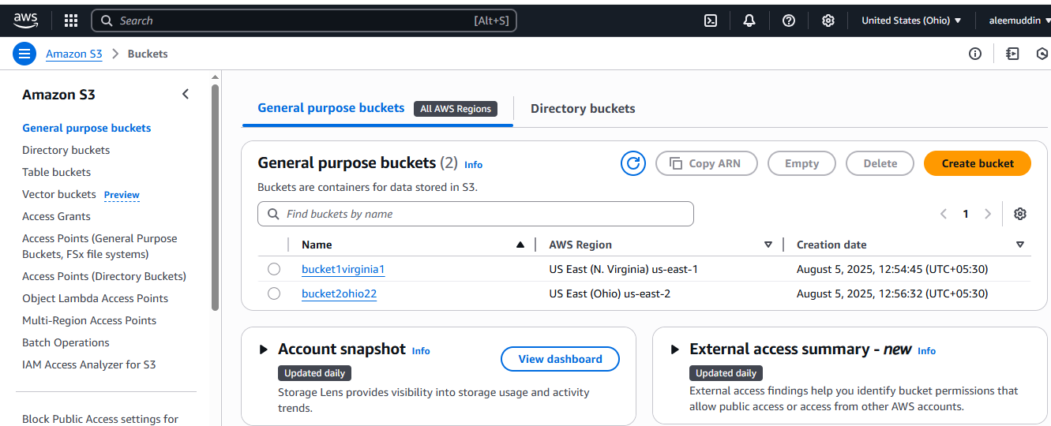

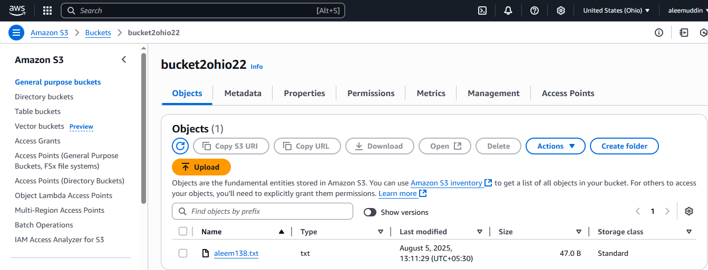

1. **Configure bucket policy, only Admin user can see the objects of s3 bucket.**

**task 4 ,**

**select bucket and in permission edit bucket policy,**

**{**

**"Version": "2012-10-17",**

**"Statement": [**

**{**

**"Sid": "DenyAllUsersExceptAdmin",**

**"Effect": "Deny",**

**"Principal": "*",**

**"Action": "s3:*",**

**"Resource": [**

**"arn:aws:s3:::aleem138",**

**"arn:aws:s3:::aleem138/*"**

**],**

**"Condition": {**

**"StringNotEquals": {**

**"aws:PrincipalArn": "arn:aws:iam::548813916475:user/Admin"**

**}**

**}**

**}**

**]**

**}**

**now in IAM create users , Admin and aleem**

**login in another browser with Admin you can access S3 bucket,**

**but login by aleem you cannot access S3 bucket**

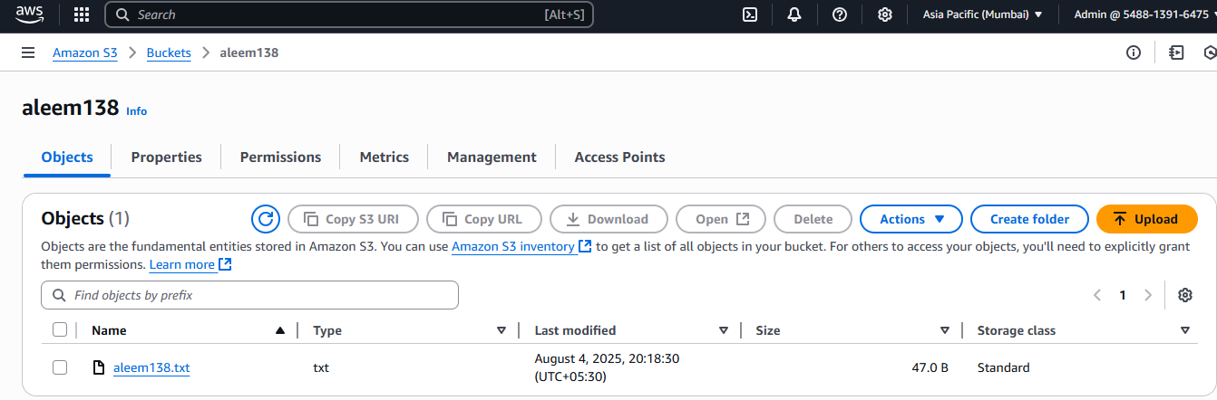

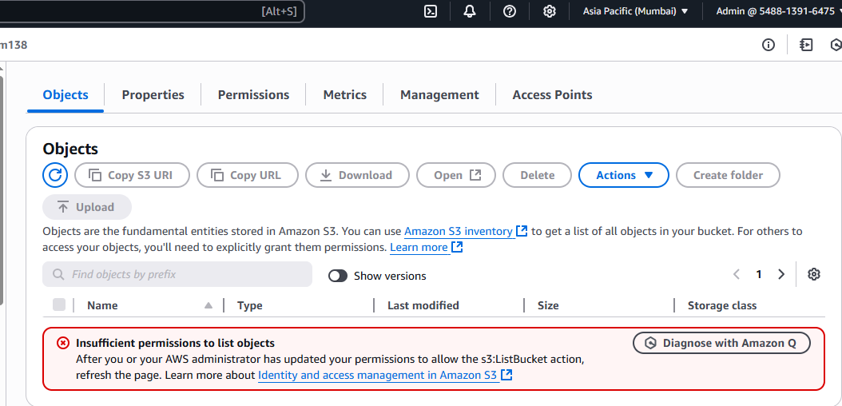

1. **Setup lifecycle policies to automatically transition or delete objects based on specific**

**Criteria.**

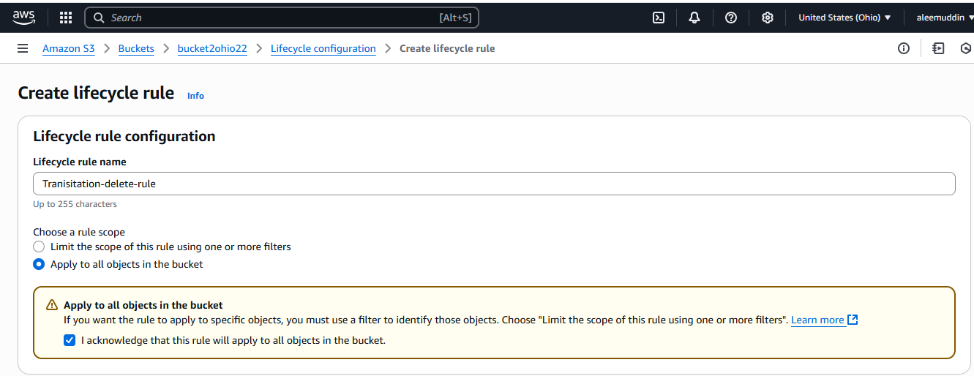

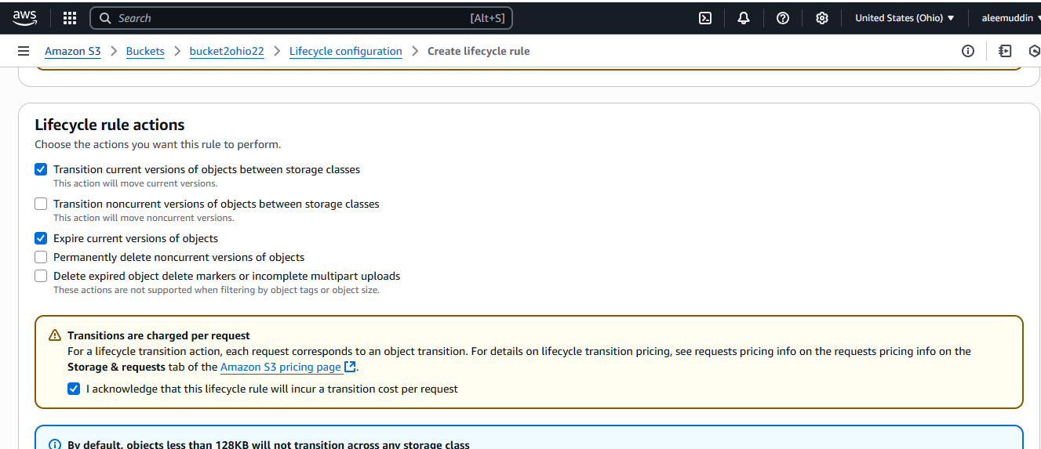

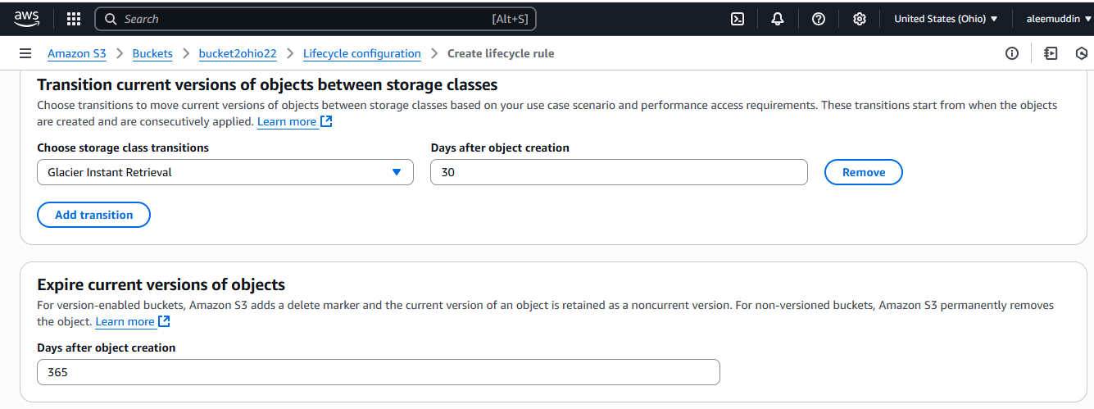

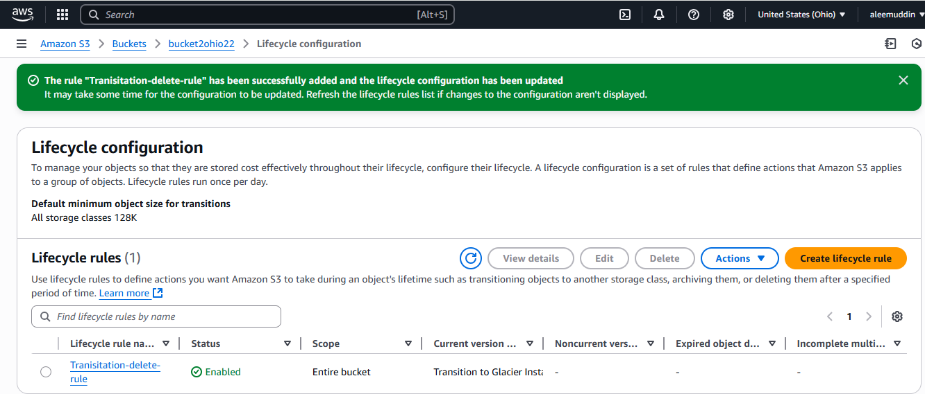

1. **Push some objects in s3 using AWS CLI.**

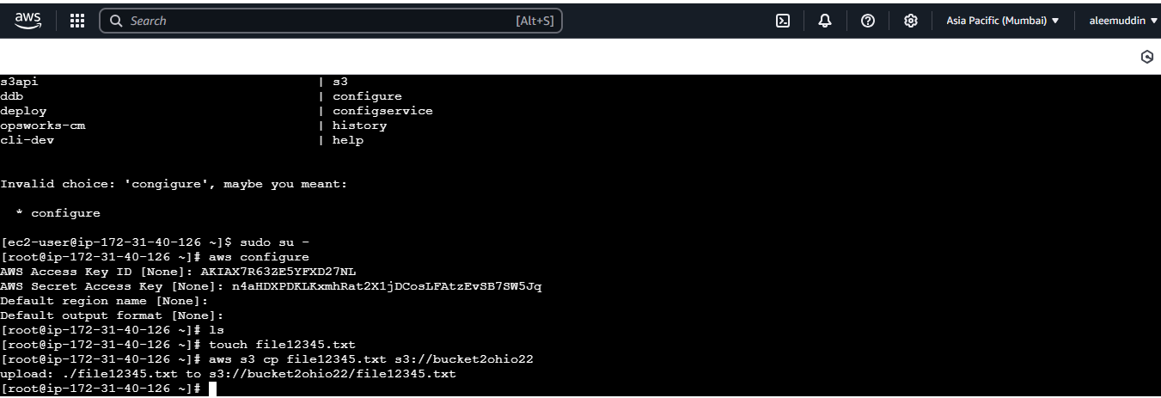

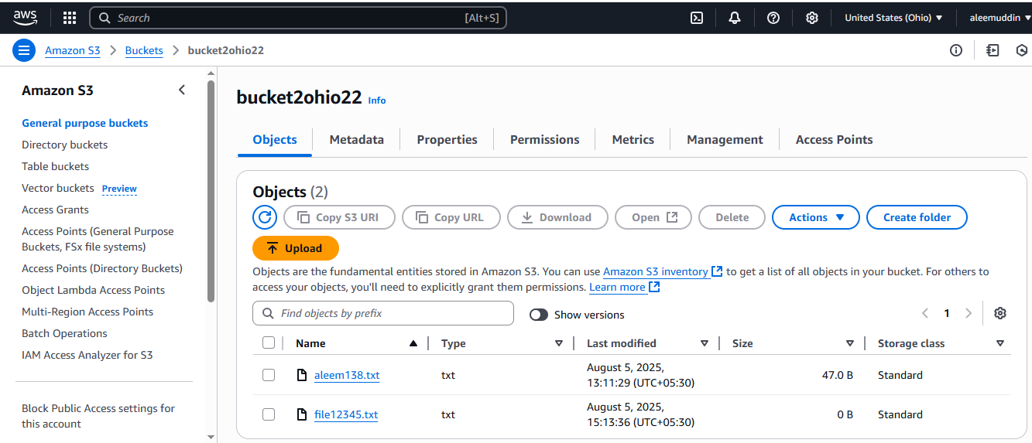

1. **Write a bash script to create s3 bucket.**

**Create s3.bash file**

#!/bin/bash

# Variables

BUCKET_NAME="aleem009988776655"

REGION="us-east-1"

# Create bucket

aws s3api create-bucket --bucket "$BUCKET_NAME" --region "$REGION"

echo "S3 bucket '$BUCKET_NAME' created in region '$REGION'."

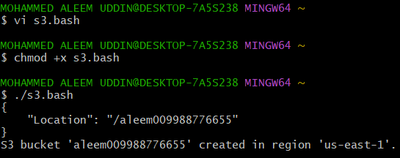

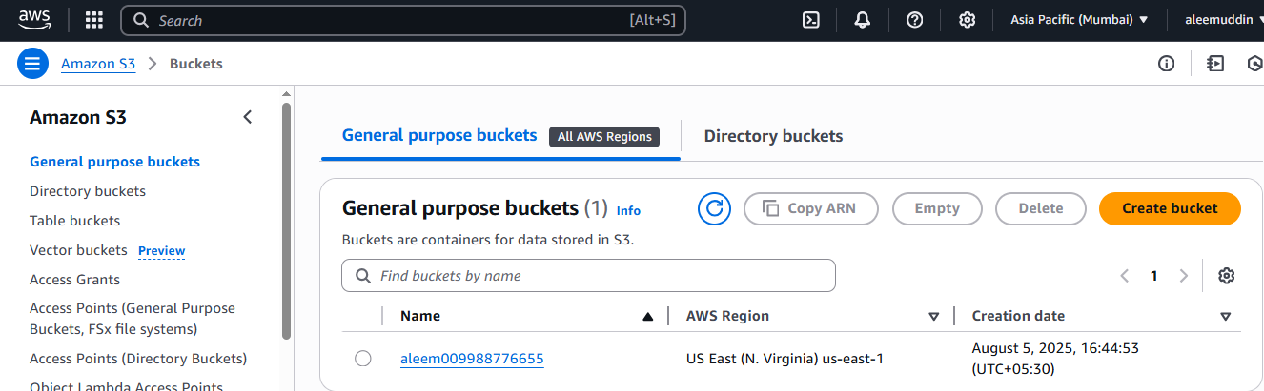

1. **Upload one 1 gb of file to s3 using cli.**

